Netwerken architectures

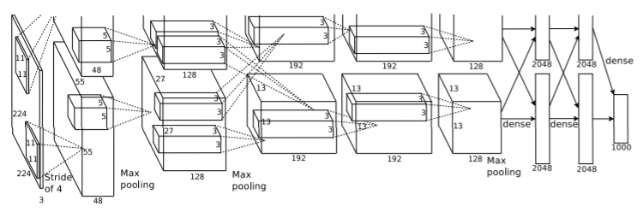

Hier is een architecture of CNN example. Ze gebruiken hier echter 2 GPU’s, weet niet of wij dat kunnen

Uitleg:

Now we are ready to describe the overall architecture of our CNN. As depicted in Figure 2, the net contains eight layers with weights; the first five are convolutional and the remaining three are fullyconnected. The output of the last fully-connected layer is fed to a 1000-way softmax which produces a distribution over the 1000 class labels. Our network maximizes the multinomial logistic regression objective, which is equivalent to maximizing the average across training cases of the log-probability of the correct label under the prediction distribution.

The kernels of the second, fourth, and fifth convolutional layers are connected only to those kernel maps in the previous layer which reside on the same GPU (see Figure 2). The kernels of the third convolutional layer are connected to all kernel maps in the second layer. The neurons in the fullyconnected layers are connected to all neurons in the previous layer. Response-normalization layers follow the first and second convolutional layers. Max-pooling layers, of the kind described in Section 3.4, follow both response-normalization layers as well as the fifth convolutional layer. The ReLU non-linearity is applied to the output of every convolutional and fully-connected layer.

The first convolutional layer filters the 224×224×3 input image with 96 kernels of size 11×11×3 with a stride of 4 pixels (this is the distance between the receptive field centers of neighboring neurons in a kernel map). The second convolutional layer takes as input the (response-normalized and pooled) output of the first convolutional layer and filters it with 256 kernels of size 5 × 5 × 48. The third, fourth, and fifth convolutional layers are connected to one another without any intervening pooling or normalization layers. The third convolutional layer has 384 kernels of size 3 × 3 × 256 connected to the (normalized, pooled) outputs of the second convolutional layer. The fourth convolutional layer has 384 kernels of size 3 × 3 × 192 , and the fifth convolutional layer has 256 kernels of size 3 × 3 × 192. The fully-connected layers have 4096 neurons each.

Krizhevsky, A., Sutskever, I., & Hinton, G. E. (n.d.). *ImageNet Classification with Deep Convolutional Neural Networks*. Retrieved from http://code.google.com/p/cuda-convnet/